To Do List

1. Create command prompt error logging
   1. Create log of errors encountered if none exists
   2. Log error in errors.log
      1. What error occurred
      2. What function it occurred in
2. Create start screen window
   1. Create initial window (mainline/hub area/import board prompt)
      1. Mainline and hub area buttons continue to the next window
      2. Import board opens the file explorer to open a CSV of a planned board and skips the next window
   2. Create second window for direction
      1. Import correspondingly named board
3. Create main UI and workspace
   1. Planning section that populates from the run queue
   2. Trailer queue
   3. Menu system
4. Create board import algorithm
   1. Since boards will be CSVs, importing them will be straightforward
      1. Load CSV into memory
      2. Go line-by-line skipping the first since it is just the names of the columns
      3. Board is stored in LANE, DEST, NAME, TRACTOR order
      4. Create a run for each line and add it to the run queue
5. Make initial menus load the following UI after the appropriate buttons are pressed.

**Dispatcher Planner Software**

Start Screen

The start screen starts off with three buttons. East and West. The buttons in this screen are populated from a folder of CSV files for each board. The button text is taken from the file name of the board.

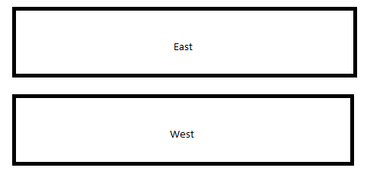

Once a plan is selected, it is loaded from a maintained board (CSV) mapping to the

Board Loading

Each plan will be loaded from a CSV that maps to the dock layout.

For instance:

|  |  |  |  |
| --- | --- | --- | --- |
| LANE | DEST | NAME | TRACTOR |
| 760 | 7732 | HAYT | 123456 |

The board will be loaded into a list where each spot in the list consists of four text boxes: lane, destination/name, tractor, and notes. The trailers will populate as empty. **Not as empties, but just an empty spot** The run can be deleted by using the “x” button in the top left.

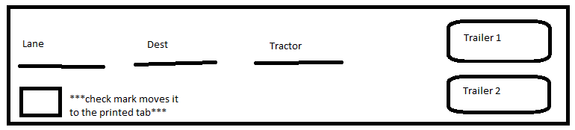

Main UI

# Main Window

The main window will consist of a planning section, the trailer queue, and the menu system. The planning section will consist of two tabs: printed, and unprinted. Planners will spend most of their time in the unprinted tab. The menu system will consist of the file menu, the runs menu, and the yard check menu. Their submenus will be explained later.

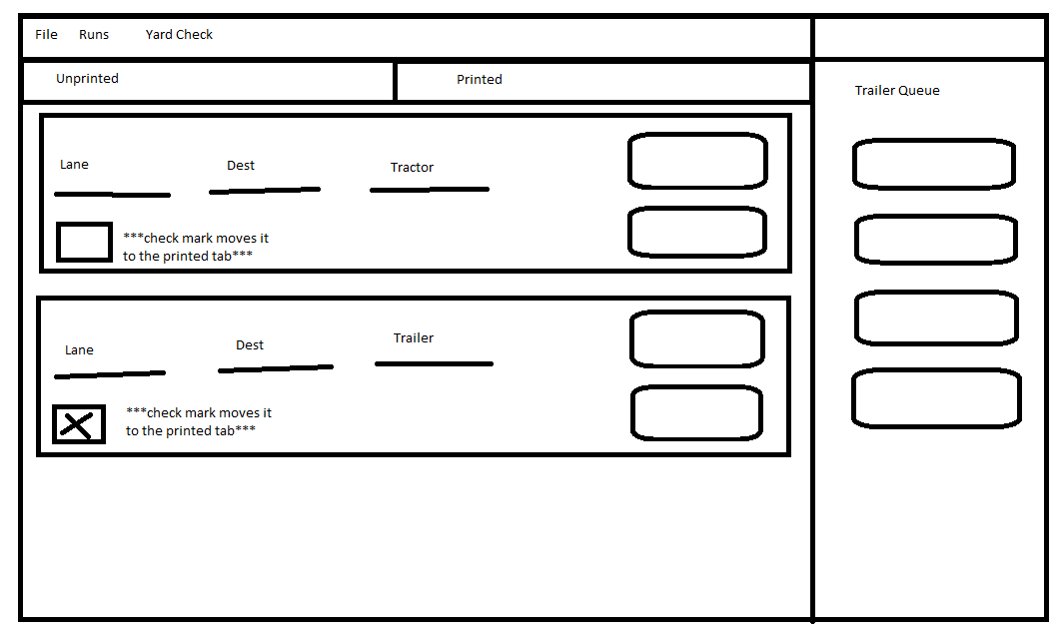

# Trailer Queue

Unplanned trailers will appear in the trailer queue on the right of the screen. These trailers will be sorted by destination. Moving a trailer from the unplanned queue will move them to the planned queue. The planned queue can be seen by switching to the planned queue tab. The default tab is the unplanned queue.

# Printed Tab

The printed tab is for runs that have been finalized, printed from TMS, and given to the drivers to hook up. They can be switched to the unprinted tab by unchecking the box in the bottom left.

# Unprinted Tab

The unprinted tab is for runs that have not been finalized. The run can be moved to the printed tab by checking the box in the bottom left.

# File Menu

The file menu will consist of four options: new board, save dedicated board, export board, and preferences.

Creating a new board will ask you to save your current one as a CSV to the desired location before deleting everything and starting a fresh board.

Saving a dedicated board will copy every run that is current on the board into new memory and open a prompt to go through each one. Each run will allow you to edit the lane, destination, name, and tractor, but have no information for the trailers. Once finished, the bottom of the list will contain a text box to name the board and a button to save it.

Exporting your board translates it to a CSV and then converts that string which can then be imported into the program.

Preferences allows you to change a myriad of options in the program.

# Runs Menu

The runs menu will consist of one option: add run.

Add run will create a window like the trailer creation window and ask for lane, destination, name, and tractor.

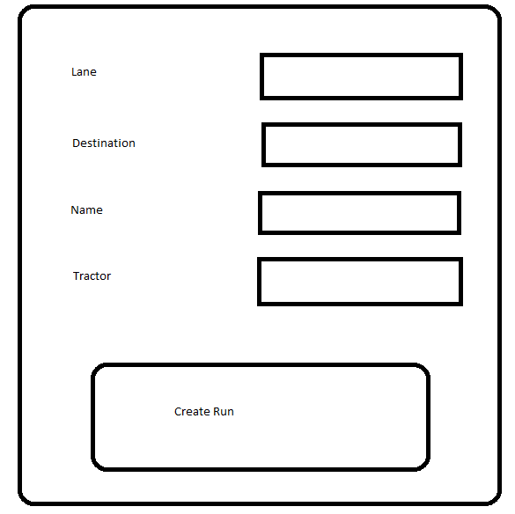

# Yard Check Menu

The yard check menu will contain one option: export to yard check.

Exporting to yard check will take all trailer numbers and their destinations and export them to CSV. This makes the yard check trivial and executable in a couple of commands.

# Trailer Menu

The trailer menu will consist of two options: create trailer, and percentage tolerances.

The create trailer menu will have two submenus: create empty and create loaded. Create empty will not open a window, but instead add an empty trailer to the top of the trailer queue. Create loaded will open a menu like create run. More details to follow.

The percentage tolerances will open a window that allows you to pick what the tolerances for the gradient are. Details on how the gradient operates to follow. You will be able to change the percentages at which the colors change along with the color using a color wheel picker, with five change points. The first range must be between 1 and 24. The second between 25 and 49. The third between 50 and 74. The fourth between 75 and 100. 0 will be for empty trailers only. The defaults will be the following:

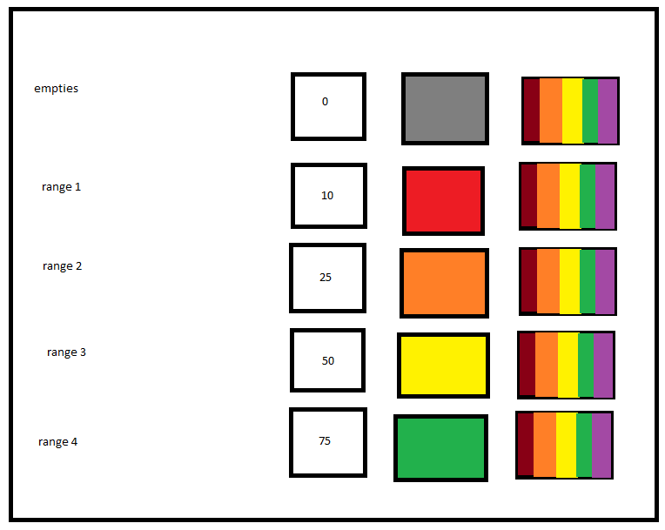



Trailer Behavior

# Trailer Creation

Trailers will be created from a popup menu that contains text input prompts for origin, destination, percentage, and trailer number read as strings except percentage.

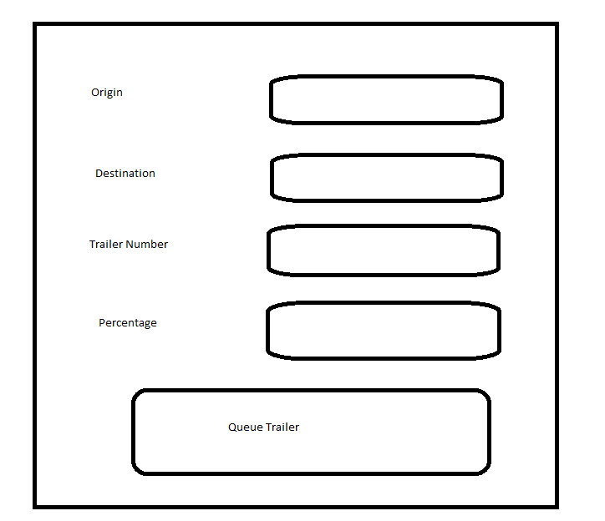

Trailers are not added to any run automatically. Instead, they are added to a queue of unplanned trailers. This queue will be visible on the right side of the screen and is detailed in the main UI.

# Style

Trailers will be a button that displays three text boxes: number, origin, and destination. Trailer percentage will be a visual sliding scale in the background of the button, along with a slider at the bottom of the button. The background will change color based on the percentage starting with gray at 0%. E.g. 10% = red, 25% = orange, 50% = yellow, 75% - 100% = green. There will also be an x to delete the trailer at the top right. An information button will be at the top right to display all information

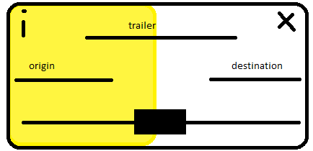

# Click and Drag

Trailer buttons will be able to be click and dragged over the screen. A blank (no trailer information) transparent button will be visible with the mouse movement.

# Swapping

Trailers will be able to be swapped by hovering a click and dragged trailer over another trailer. When a trailer is in “swap mode”, it will dim the button and display the swap icon above it.

